**END OF YEAR PROJECT FOR 3 ISI SUP MTI**

**Table of contents**

1. Chapter 1. General Introduction
2. Introduction
3. Project overview
4. Project objectives
5. Project limitations
6. Project organization’
   1. Human resources
   2. Methodology adopted
   3. Why Gantt
7. Chapter 2. Study of the existing
8. Digital marketing
   1. Statistics overview
   2. References
9. Key factors for success
   1. References
10. Understanding customer needs
    1. References
11. Competitive advantage
12. Effective marketing strategy
13. Conclusion
14. Chapter 3. Functional requirements and technical study
15. Introduction
16. Functional requirement
17. Non-functional requirement
18. Technical study
19. Tools and technologies
20. Chapter 4. Design and Conceptual study
21. Introduction
22. Class diagram

1.1 data dictionary

1. Use case diagram
2. Sequence diagram
3. Conclusion
4. Implementation/development of EasyLife

**List of Tables**

* 1. Table 1.1

**List of Abbreviations**

* 1. SSL – secured sockets layer

**CHAPTER 1**

**GENERAL INTRODUCTION**

**INTRODUCTION**

This chapter serves as an introductory overview of the project, aiming to provide a comprehensive understanding of its scope, objectives, limitations, and the chosen engineering process. By the end of this chapter, readers will have a solid grasp of the project's concept, its underlying goals, the constraints it operates within, and the methodology employed for its execution.

**PROJECT OVERVIEW**

Easylife is a dynamic and feature-rich Java-based application that empowers users with a wide range of functionalities and seamless access to essential services. The application caters to diverse needs, including a robust online store that facilitates efficient product search, purchase, and order management.

In today's rapidly evolving society, the demand for high-quality technology services continues to escalate. Recognizing this trend, our team at Easylife is driven by the passion to offer individuals an innovative e-commerce solution that enhances their lifestyle while saving them valuable time, money, and effort. Our primary objective is to simplify the complex process of online shopping, transforming it into a convenient and user-friendly experience that can be accomplished with just a few clicks.

At the core of our mission is the belief that technology should empower and enrich lives. With this vision in mind, we have meticulously crafted Easylife to serve as a cutting-edge platform, delivering seamless integration of advanced technology into the daily lives of our users.

Easylife provides an array of essential features, allowing users to effortlessly create personalized accounts, browse through an extensive selection of products, conduct targeted searches, and securely place orders. Furthermore, the system incorporates robust administrative capabilities, enabling super users or administrators to efficiently manage products and oversee all aspects of the platform's services.

As we embark on this exciting journey, we are committed to delivering a comprehensive, user-centric experience through Easylife. We envision a future where technology revolutionizes the way people shop, making it simpler, more efficient, and ultimately enhancing their overall quality of life.

Through Easylife, we aim to redefine the online shopping landscape, offering a seamless and enjoyable experience that meets the ever-evolving demands of our users. Together, let us embrace the transformative power of technology and embark on a journey towards a more connected and convenient future.

**PROJECT OBJECTIVES**

Easylife is dedicated to assisting users in making efficient purchases and gaining knowledge about essential products for their daily lives. One of the greatest challenges we all encounter is managing our time effectively, whether we are working professionals, nursing mothers, students, teenagers, or adults. Easylife aims to alleviate this burden by providing a streamlined system that enables individuals to find and purchase high-quality products, saving them valuable time and eliminating the need to navigate through traffic in search of a suitable store.

Moreover, Easylife recognizes that people may have the time to shop but struggle with identifying trustworthy brands. Our application exclusively offers products from reputable and reliable brands, ensuring that users can make informed purchasing decisions with confidence.

Additionally, some individuals may be interested in certain products but are not ready to make a purchase immediately. Easylife addresses this concern by allowing users to add desired items to their Wishlist, providing them with the option to revisit and purchase those products at a later time. This feature enables users to plan their purchases according to their budget and preferences.

Furthermore, Easylife caters to users who wish to buy products for their loved ones on special occasions, such as birthdays, surprise parties, anniversaries, and more. The application provides a seamless shopping experience, allowing users to select and send thoughtful gifts to their dear ones with ease.

In summary, our objectives encompass the following key functionalities:

1. Search for products: Users can easily explore and discover a wide range of products through our intuitive search feature.
2. Add to Wishlist: Users can save desired products to their Wishlist for future reference and consideration.
3. Add to cart: Users have the ability to add selected items to their cart, creating a convenient way to manage their intended purchases.
4. Make an order: Users can proceed to place orders for the products they have selected, initiating the purchasing process.
5. Confirm payments: Easylife offers a secure payment gateway, ensuring smooth and reliable transactions for users to complete their purchases with confidence.

**PROJECT LIMITATIONS**

Easylife is committed to partnering with manufacturers of trusted brands to ensure the provision of high-quality services to our users and maintain the trustworthiness of our application. However, achieving this objective requires significant investments, thorough investigations, rigorous testing, and ongoing trials.

One aspect that sets us apart from other similar products is our emphasis on working exclusively with trusted brands. This unique approach strengthens our position in the market. Nevertheless, we understand that in order to continually enhance our services and maintain our partnerships, we must actively engage in surveys and gather customer feedback to drive continuous improvement.

By actively seeking input from our users and closely monitoring their experiences, we can adapt our strategies, refine our processes, and ensure that our services consistently meet their expectations. Building a strong network of trusted brands is a continuous endeavor, and we are dedicated to maintaining the highest standards of quality and reliability in the products we offer.

Together, we can overcome these limitations and establish Easylife as a leading platform for delivering exceptional products and services to our valued users.

**PROJECT ORGANIZATION**

Our project is structured in a manner that facilitates efficient task completion. We have developed an organizational framework based on the first version of our application, which will enable us to effectively execute our project plan.

**1.1 Human Resources**

The project involves a team of supervisors who oversee the work of engineers responsible for examining the codes prior to integration. In terms of human resources, the team includes:

1. Mr. Blessed Tasela Kohworho
2. Madame Hind Driouche
3. Mr. Soufiane Hamid

|  |  |
| --- | --- |
| Name | Role |
| Mr. Soufiane Hamid | Project supervisor |
| Mr. Blessed Tasela Kohworho | Team Member |
| Miss Hind Driouche | Team Member |

Table 1.1

**1.2 Methodology Adopted**

In order to achieve a cohesive and high-value application, we recognize the need for a development model that is both straightforward and precise. It is crucial that this model accurately describes an efficient and complete modeling structure of the system, by following and validating sequential steps throughout the development phase, and passing all tests to ensure optimum operation. Therefore, we have selected the GANTT chart as our chosen development model. This chart provides us with a visual representation of the tasks involved, their duration, and the dependencies between them. We believe that this model will help us to effectively manage our project and ensure that we deliver a high-quality product on time and within budget.

**1.3 Why GANTT**

The Gantt chart is a useful tool for visualizing the timeline of tasks and activities required for the implementation of the first version of our application. It provides an overview of the project timeline and the duration of each task, allowing us to effectively track our progress in real-time and identify any potential issues or delays that may arise during the project's development. This information enables us to take corrective actions promptly as needed, ensuring the project stays on track. In addition to improving project efficiency, Gantt charts facilitate communication and collaboration, ensuring that each task is completed in the correct order. Overall, the Gantt chart is an essential tool for ensuring the success of our project.

The Gantt planning would be implemented soon.

**CHAPTER 2**

**STUDY OF THE EXISTING**

**INTRODUCTION**

This chapter is dedicated to conducting an in-depth analysis of the existing market landscape and similar products. Our objective is to develop effective market strategies by examining competitors, understanding customer needs, and identifying emerging market trends. Through comprehensive real-life studies, we aim to uncover valuable insights that will enable us to enhance our application and provide exceptional services to our users.

By delving into the market dynamics, we can gain a deeper understanding of the competitive landscape and identify areas of opportunity. This analysis will serve as a foundation for refining our strategies and ensuring that we stay ahead of the curve in meeting the evolving demands of our target audience.

Through meticulous research and thorough examination of the market, we will gather valuable data and insights that will inform our decision-making process. This will enable us to make informed choices, optimize our resources, and shape our application to deliver optimal value and user satisfaction.

Our team of dedicated professionals will collaboratively assess the findings and formulate actionable recommendations. By leveraging the knowledge gained from this study, we will be able to refine our approach, enhance our competitive edge, and drive continuous improvement in the delivery of our services.

We extend our gratitude to the team members and supervisors for their valuable contributions and commitment to this comprehensive study. Together, we will leverage these insights to position our application for success and ensure that we continue to meet and exceed the expectations of our users.

**OBJECTIVE OF THE STUDY**

The primary objective of this study is to gain a comprehensive understanding of the current status and trends within the digital market. By conducting a thorough analysis, we aim to uncover valuable insights that will enable us to differentiate our product and establish a strong presence in the competitive e-commerce industry.

Specifically, the study will focus on the following objectives:

1. Assessing the current state of the digital market: We will examine the existing landscape to identify the prevailing market trends, customer preferences, and emerging patterns.
2. Identifying key factors for success: By studying successful players in the e-commerce industry, we will identify the critical factors that contribute to their achievements. This includes analyzing their business models, customer engagement strategies, marketing approaches, and innovative practices. We will leverage these insights to shape our own strategies and position our product for success.
3. Understanding customer needs and expectations: Through market research and customer analysis, we will gain valuable insights into the needs, preferences, and pain points of our target audience.
4. Uncovering competitive advantages: By studying our competitors, we will assess their strengths, weaknesses, and market positioning. This analysis will help us identify opportunities to differentiate our product and offer unique value propositions to our customers. We will strive to leverage our competitive advantages to gain a strong foothold in the market.
5. Formulating effective strategies: Based on the findings of the study, we will develop comprehensive strategies that encompass product development, marketing, customer acquisition, and retention. These strategies will be aligned with industry trends and customer expectations, enabling us to position our product as a leading solution in the e-commerce industry.

**DIGITAL MARKETING**

The digital marketing industry is experiencing rapid growth, and there is a wealth of valuable statistics that shed light on its current state. These statistics cover various aspects, such as the number of social media users and the expenditure on digital advertising. By analyzing these metrics, we can gain valuable insights into the current landscape of the digital marketing industry.

**STATISTICS OVERVIEW**

In the digital marketing industry, there are several important statistics that provide valuable insights into the current state of the market. Here is a summary of the key statistics:

1. Projected Growth: By 2026, the Digital Marketing industry is expected to reach $807 billion, with mobile phones accounting for 69% of ad spending.
2. Market Growth: The global digital advertising and marketing market is estimated to grow from $350 billion in 2020 to $786.2 billion by 2026, with a compound annual growth rate of 9%.
3. Content Marketing and SEO: 82% of marketers are actively investing in content marketing, with 40% of B2B marketers having a documented content marketing strategy and 69% investing time in SEO.
4. Shift to Mobile: Ad spending is shifting from desktop to mobile phones, emphasizing the need for optimizing campaigns for mobile devices.
5. Importance of Digital Marketing: Digital marketing is increasingly important for businesses of all sizes, with digital advertising spend projected to exceed offline advertising spend.
6. SEO and Website Traffic: Search engine optimization (SEO) plays a critical role in driving website traffic, as 68% of online experiences begin with a search engine.
7. Content Marketing Strategy: Having a documented content marketing strategy and investing in SEO are key factors for success, as content marketing continues to grow.
8. Effectiveness of Email Marketing: Email marketing revenue is projected to reach $10 billion by 2023, with email campaigns offering coupons having higher purchase rates.
9. Importance of social media: social media is essential for marketing, with 92% of marketers using it and 67% of consumers expecting brands to have a social media presence.
10. Facebook and Instagram: Facebook is the most popular platform for digital marketers, responsible for 25% of all digital ad spending, while Instagram is also influential with high user engagement.

These statistics highlight the growth and importance of digital marketing, emphasizing the significance of content marketing, SEO, email marketing, and social media in effective marketing strategies.

**REFERENCES**

1. <https://www.demandsage.com/digital-marketing-statistics/#:~:text=General%20Digital%20Marketing%20Statistics,smartphones%20take%20the%20remaining%2061%25.&text=Non%20Programttic%20ad%20spending%20holds,%2C%20while%20programmatic%20holds%2084%25>
2. <https://www.wordstream.com/blog/ws/2022/04/19/digital-marketing-statistics>
3. <https://ahrefs.com/blog/seo-statistics/>
4. <https://www.onthemap.com/blog/seo-statistics/>
5. <https://ahrefs.com/blog/content-marketing-statistics/#:~:text=67%25%20of%20marketers%20report%20that,3%25%20increase%2C%20CMI>)
6. <https://www.statista.com/topics/1650/content-marketing/#topicHeader__wrapper>
7. <https://www.statista.com/topics/1446/e-mail-marketing/#:~:text=As%20the%20number%20of%20e,10%2Dbillion%2Ddollar%20threshold>
8. <https://marketsplash.com/email-marketing-statistics/>
9. <https://nealschaffer.com/social-media-marketing-statistics/#:~:text=Social%20Media%20Marketing%20Statistics%20FAQs,-What%20percentage%20of&text=A%20whopping%2093%25%20of%20marketers,using%20social%20media%20for%20marketing>
10. <https://sproutsocial.com/insights/social-media-statistics/>

**KEY FACTORS FOR SUCCESS**

To excel in delivering the best services through our application and stay ahead of the competition, we have identified the following key factors that will propel us forward:

1. Product Pricing Regulation: We will utilize various pricing strategies to find the right balance between attractiveness and earnings. This includes keystone pricing, discount pricing, psychological pricing, competitive pricing, and value-based pricing. Regularly comparing prices with competitors using tools like Import.io will help us stay competitive.
2. Maintaining High-Quality Products: Our application will only work with trusted brands to ensure the delivery of high-quality products that meet customer needs. Transparency in system feedback and taking prompt corrective actions will be prioritized. Continuous improvement in product quality will be a part of our ongoing process.
3. Improving Store Accessibility: Our application will be designed to accommodate all types of customers, including people with disabilities and from different cultures. We will ensure accessibility features such as high-contrast visual themes, larger font sizes, and language options. Implementing responsive design and optimizing images for faster loading will enhance the overall accessibility of our online store.
4. Making a Wonderful First Impression: Creating an eye-catching design for our application is crucial to make a positive first impression on users. We will focus on providing an appealing and user-friendly interface to entice customers and encourage them to explore and use our e-commerce website.
5. Securing Shipment: Addressing security concerns is vital for both entrepreneurs and consumers in the e-commerce industry. We will prioritize the security of customer data by implementing SSL encryption to protect transactions and personal information. Two-factor authentication and other verification methods will be incorporated in future updates to further enhance security.
6. M-Commerce Readiness: Our application being mobile-based gives us an advantage as the mobile user base has grown significantly in recent years. We will optimize our online store for mobile commerce by incorporating responsive design, easy-to-use navigation menus, robust mobile search features, and streamlined checkout and payment processes.

By focusing on these key factors, we aim to provide an exceptional user experience, build trust with customers, ensure the quality of products and services, and maintain a secure and accessible platform.

**REFERENCES**

1. <https://www.import.io/>
2. <https://zyro.com/blog/how-to-start-an-online-store/>
3. <https://redstagfulfillment.com/virtual-reality-drastically-enhancing-ecommerce-shopping-experience/>

**UNDERSTANDING CUSTOMER NEEDS**

To ensure we consistently deliver on our promises to customers and understand their needs, we will implement the following practical tips:

1. Team Member Questions:

- Each team member will answer questions about our main customers, the market they belong to, how our product or service meets their needs, and what further assistance they require.

- This exercise will help us gain insights into our customers and align our efforts accordingly.

2. Stepping into Customer Shoes:

- Each team member will put themselves in the shoes of one of our key customers and identify their challenges and needs.

- They will consider what they would require while using our product or service and what would make their experience easier or better.

- The team will reflect on these insights to identify areas for improving customer service.

3. External Surveys:

- We will utilize external customer surveys to measure current satisfaction levels before and after implementing our customer service improvement plan.

- Tools like Survey Monkey can be used for quick, cost-effective surveys, or we can consider employing an external agency.

- We will map out the aspects of customer service to measure, covering the entire service journey.

4. Analyzing Customer Feedback:

- We will analyze feedback from customers to identify trends and gaps in our service and product offerings.

- The team will share the results and determine the best ways to address gaps and build upon the elements valued by customers.

5. Personal Feedback from Customers:

- We will seek personal feedback from customers at different stages of the buying process.

- Reservation Time: We will ask how well we met their needs during the selection process and what improvements could have been made.

- After Purchase: We will inquire about the satisfaction level and ask for suggestions to achieve a perfect score.

- After Sales Service: We will follow up after a designated period and ask for feedback on their experience and any areas for improvement.

- We will make the feedback process simple, quick, and easy to complete, whether through online platforms, telephone conversations, or email.

**REFERENCES**

1. <https://www.ksl-training.co.uk/free-resources/customer-service/how-to-improve-customer-service/>
2. <https://www.surveymonkey.com/>

**COMPETITIVE ADVANTAGE**

To establish a competitive advantage and differentiate ourselves from competitors, we have identified the following factors:

1. High-Quality Customer Service: In a world where exceptional customer service is becoming rare, we will prioritize providing top-notch customer care. Taking inspiration from successful companies like Apple, Amazon, and Walmart, we will make customer service our hallmark. This focus on high-quality customer service will be implemented in future versions of our application.
2. Competitive Pricing: Recognizing that price plays a significant role in customers' purchasing decisions, we will optimize our services to offer prices that are hard to beat. While maintaining our profit margins, we will ensure that customers feel they are receiving excellent value for their money.
3. Unique Offers: Setting ourselves apart from other companies in our industry, we will provide unique offers that capture customers' attention. For example, we can introduce special promotions such as one-day Black Friday sales, offering massive discounts on all products. These exclusive deals will attract customers and create a sense of urgency and excitement.
4. Trustworthiness of our Brand: We will work exclusively with trustworthy brands, ensuring that our identity and reputation are not compromised. By following rigorous processes and adhering to strict standards, we will maintain the trust of our customers, further enhancing our competitive advantage.

**EFFECTIVE MARKETING STRATEGY**

Effective Marketing Strategy includes the following;

1. Define Our Project's Value:

Identify the main benefits and unique selling points of our project. Determine what sets it apart from other internal initiatives and how it provides value to our organization. Consider the impact it will have on our target audience or stakeholders and the problem it solves.

2. Understand Our Target Audience:

Collaboratively analyze and define the target audience for our project within our organization. Conduct research and analysis to identify their characteristics, preferences, and needs. Gain insights into their motivations, pain points, and behaviors to better tailor our marketing efforts.

3. Develop Customer Personas:

Create detailed customer personas or profiles that represent different segments of our target audience within the organization. These personas should include demographic information, job titles, goals, challenges, values, preferred communication channels, and any other relevant characteristics. This will help the team better understand and connect with the audience.

4. Set Clear Objectives:

Work together to establish measurable goals and objectives for our marketing strategy. These goals should align with the overall project objectives and be specific, measurable, achievable, relevant, and time-bound (SMART). Ensure that they are well-communicated and understood by all team members.

5. Determine Key Performance Indicators (KPIs):

Identify the key metrics that will be used to evaluate the success of our marketing efforts. These could include project adoption rate, user engagement, feedback and satisfaction, productivity improvements, or any other relevant metrics. Establish benchmarks and targets to track progress and measure the effectiveness of our marketing activities.

6. Collaborate on Marketing Tactics:

Engage in brainstorming sessions to generate creative marketing ideas and tactics that align with the project's goals and target audience within our organization. Encourage all team members to contribute their perspectives and expertise. Explore various marketing channels, such as internal communications platforms, presentations, workshops, or targeted campaigns, based on our audience's preferences.

7. Implement and Monitor:

Assign responsibilities to team members based on their strengths and expertise. Develop a detailed marketing plan with specific tasks, timelines, and milestones. Regularly monitor and track the progress of our marketing activities, making adjustments as necessary. Foster effective communication and collaboration among team members to ensure smooth execution.

8. Measure and Analyze Results:

Continuously measure and analyze the performance of our marketing efforts against the defined KPIs. Utilize analytics tools, user feedback, and performance data to evaluate the effectiveness of our strategies and tactics. Identify areas of success and areas that need improvement, and use these insights to refine our marketing approach.

**CONCLUSION**

In conclusion, studying the existing marketing landscape and understanding our competitive advantage is crucial for the success of our java application. By defining our project's value, identifying our target audience, setting measurable goals, and developing customer personas, we can create a focused and effective marketing strategy. Collaboration among team members and supervisors is key in brainstorming marketing tactics and implementing the plan. Regular monitoring, analysis, and adjustment of our marketing efforts will help us measure results and make necessary improvements. With a well-executed marketing strategy, we can effectively promote our product and drive its adoption within our organization.

**CHAPTER 3**

**FUNCTIONAL REQUIREMENTS AND TECHNICAL STUDY**

**INTRODUCTION**

This chapter aims to outline the functional and non-functional requirements of our application and conduct a technical study to determine the appropriate tools and technologies. It serves as the initial phase in realizing the application, providing a clear and unambiguous description of the application to be developed. Additionally, this chapter initiates the architectural design process of our application.

**FUNCTIONAL REQUIREMENTS.**

Based on extensive research and analysis of existing products in the market, we have identified the core functional requirements of our system. These requirements enable users to search for specific products and make purchases. Let's delve into the details of these functionalities:

**1.1 Authentication**

Authentication is required for all users. Users must provide a username and password to validate their identity. Authentication data is retrieved from our database, where users are stored and categorized based on their privileges. This ensures data security and protects the application.

Functionalities of authentication:

1. Login: Users can securely log into the system using their credentials.
2. Password recovery: Users can recover their passwords through a secure process.

**1.2 Registration**

Super users must register before gaining access to the application's functionalities. By registering and getting authenticated, super users enjoy additional privileges such as managing products, orders, and tracking payments. Registration for normal users comes with added advantages, such as potential discounts on purchases. User information is stored in the user table of our database.

Functionalities of registration:

1. User registration: Super users and normal users can register their accounts with the application.
2. Admin registration: Super users can register their administrative accounts for enhanced access and control.

**1.3 Payment**

Payment must be made before a product can be delivered. Validated orders are processed, and the total amount is returned to the user for payment.

Payment functionality:

1. Secure credit card information handling

**1.4 Manage Products**

Super users have the authority to manage products, which involves various functionalities, including adding new products, updating existing products, and deleting products.

**1.5 General functionalities**

1. Product information: Users can access comprehensive information about each product.
2. Product search: Users can search for specific products based on various criteria.
3. Adding to cart: Users can add desired products to their cart for subsequent purchase.

**1.6 Purchase Product**

Customers can purchase products by adding them to the cart and proceeding with the order and payment process.

Functionalities include:

1. Placing an order: Users can place an order for the selected products in their cart.
2. Making payment: Users can securely make payments for their orders, ensuring a smooth transaction process.

**1.7 Manage Order**

Super users are responsible for managing orders, including order confirmation, order processing, and confirming payments.

**1.8 Feedback/Review**

Users can provide feedback to help improve the application. This includes sending feedback and reviewing the application. Super users have the ability to review and respond to user feedback.

**ACTORS**

1. Clients
2. Admin

**1.1 Clients**

Clients are customers who engage with the system for purchases. Their objective is to seamlessly browse products, make informed purchase decisions, and complete secure transactions.

**Functionalities of Clients:**

1. Creating an account: Clients can create personal accounts to enhance their shopping experience.
2. Logging in: Clients can securely log into their accounts to access personalized features.
3. Browsing products: Clients can explore a wide range of products available in the application.
4. Searching for products: Clients can search for specific products based on various criteria such as keywords, categories, or filters.
5. Adding to Wishlist: Clients can save desired products to their Wishlist for future reference and easy access.
6. Adding to cart: Clients can conveniently add products to their cart for purchase.
7. Placing an order: Clients can proceed with the order placement process for selected products.
8. Tracking orders: Clients can track the status and progress of their orders to stay informed.
9. Making payments: Clients can securely complete payment transactions for their orders.

**1.2 Admin**

Admins are super users with administrative privileges. Their objective is to effectively manage the application, oversee product-related activities, and ensure smooth order processing.

**Functionalities of Admins:**

Admin performs all functionalities of clients with added admin privileges

1. Managing products: Admins can perform actions such as adding new products, updating existing ones, and removing products.
2. Tracking orders: Admins can monitor and manage the status and progress of orders within the system.
3. Managing orders: Admins can process, update, and delete orders as necessary to ensure smooth order processing.

**NON-FUNCTIONAL REQUIREMENTS**

To ensure optimal user experience and system performance, we have identified the following non-functional requirements:

1. Easy and user-friendly interface: The application will provide a user-friendly, intuitive, and accessible interface, guiding users seamlessly throughout their shopping experience.
2. High performance: The application will be responsive with fast page load times, achieved through optimized code and efficient database indexing and design.
3. Security: The application will implement robust security measures, including secure payment processing and user authentication, allowing only authenticated users to perform actions within the application.

**TECHNICAL STUDY**

The goal of the technical study is to determine the architecture and the technologies that will be deployed in our project. Following a 3-tier architecture, our application consists of the following layers: the presentation layer, the business layer, and the database layer. The client application (frontend) is developed using NetBeans, the backend application (business logic) is developed using Eclipse, and the database is built using MySQL.

**TOOLS AND TECHNOLOGIES USED**

**DATABASE.**

**1.1 MYSQL**



MySQL is an open-source relational database management system (RDBMS) that is widely used for storing and managing data. It is known for its reliability, scalability, and performance.

**DEVELOPMENT ENVIRONMENT**

**1.1 Eclipse**



Eclipse is a popular integrated development environment (IDE) widely used for Java development. It provides a powerful Java editor with a range of features to enhance your coding experience.

**1.2 NetBeans**



NetBeans is another popular integrated development environment (IDE) that supports Java development. It provides a feature-rich Java editor with various capabilities to improve your coding productivity

**COLLABORATION TOOLS**

**1.1 Git**

Git is a highly popular version control system that enjoys widespread usage in the present day. It is an advanced open-source project that continues to be actively maintained. Initially created in 2005 by Linus Torvalds, the renowned creator of the operating system kernel, Git has gained significant recognition and adoption within the software development community.

**1.2 GitHub**

 GitHub is a web service that facilitates hosting and management of software development projects by leveraging the power of Git version control software. It offers both paid business accounts and free accounts for open-source software projects. In addition to version control, GitHub provides a range of features including access control, collaboration tools, bug tracking, feature requests, and task management. These functionalities enable teams to effectively collaborate, track issues, and manage project development in a streamlined manner.

**SOFTWARE**

* 1. **Java**



Java is a versatile and widely-used programming language known for its object-oriented approach and platform independence. It supports concepts such as encapsulation, inheritance, and polymorphism, allowing developers to write modular and reusable code. Java programs can run on any platform with a Java Virtual Machine (JVM), making them highly portable. The language provides a rich standard library with pre-built classes and methods for various tasks, simplifying development and speeding up the programming process. Overall, Java is a powerful and popular language for developing a wide range of applications.

**DESIGN TOOLS**

* 1. **Visual paradigm**



Visual Paradigm is a software tool used for visual modeling and diagramming in various domains, including software development, system analysis, and business process modeling. It provides a comprehensive set of features and functionalities to support the entire software development lifecycle.

**1.2 Team Gantt**

 TeamGantt is an online project management tool that focuses on visual project planning and scheduling. It offers interactive Gantt charts for creating project timelines, task management features, collaboration and communication tools, and resource management capabilities. It helps teams stay organized, track progress visually, and facilitates effective collaboration and communication.

**CONCLUSION**

In conclusion, this chapter provided an overview of the application's structure, highlighting its various modules and their respective functionalities. Additionally, it presented a comprehensive analysis of both the functional and non-functional requirements necessary for the development of the application.

The second part of the chapter focused on describing the architecture of the solution and the technologies employed. This technical analysis phase served as a foundation for understanding the implementation details and guiding the subsequent concept phase, which will be covered in the following chapter.

By addressing both the functional and technical aspects, this chapter lays the groundwork for a detailed exploration of the application's functionalities and the subsequent planning and execution of the development work.

**CHAPTER 4**

**DESIGN AND CONCEPTUAL STUDY**

**INTRODUCTION**

This chapter is dedicated to the design phase of the application, which involves utilizing the capabilities of Unified Modeling Language (UML) to move beyond a basic informal description. UML allows us to describe the system in a detailed manner, enabling its effective implementation.

The design phase holds significant importance in the software development cycle as it follows the requirements analysis and specification phases. It serves as a crucial stage of reflection where the system's design is carefully planned and structured.

In this chapter, we will provide an in-depth presentation of the project design through various UML diagrams, including use case diagrams, sequence diagrams, and class diagrams. These diagrams will offer a comprehensive understanding of the system's behavior, interactions, and structure, aiding in the successful execution of the project.

**CLASS DIAGRAM**

A class diagram illustrates the static view a system by showing classes, their attributes, methods, and relationships with other classes. It provides an overview of the classes and their interactions, helping to visualize the static aspects of the system's design.

In a class diagram, each class is represented as a box, containing the class name, attributes, and methods. The relationships between classes are depicted using different types of lines, indicating associations, dependencies, inheritance, and more.

The class diagram serves as a blueprint for the system's implementation and helps in understanding the organization of classes, their responsibilities, and the relationships between them. Below is the class diagram of our system

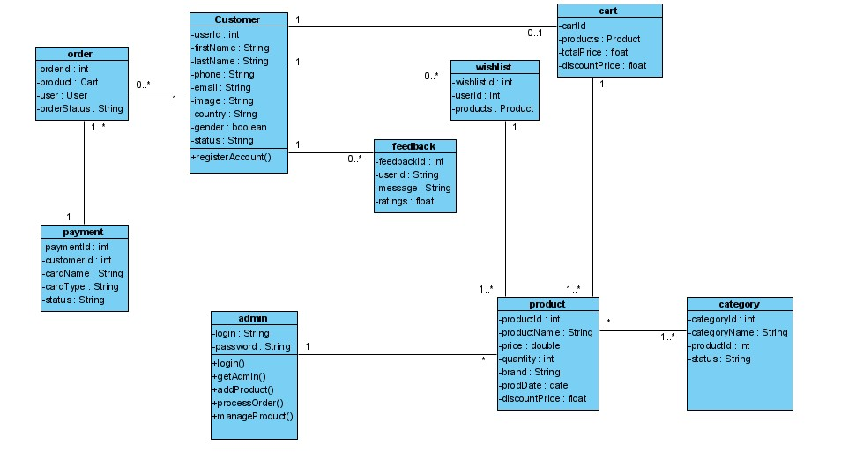

The lines show the relationship (association between the classes

The classes are the boxes which contains attributes and methods of the class

**DATA DICTIONARY**

* 1. register user

|  |  |  |  |
| --- | --- | --- | --- |
| Field | Type | Description | Example |
| userId | INT |  |  |
|  |  |  |  |
|  |  |  |  |
|  |  |  |  |
|  |  |  |  |
|  |  |  |  |
|  |  |  |  |

Table 4.1

* 1. user

|  |  |  |  |
| --- | --- | --- | --- |
| Field | Type | Example | Description |
|  |  |  |  |
|  |  |  |  |
|  |  |  |  |
|  |  |  |  |
|  |  |  |  |
|  |  |  |  |
|  |  |  |  |

* 1. admin

|  |  |  |  |
| --- | --- | --- | --- |
| Field | Type | Example | Description |
|  |  |  |  |
|  |  |  |  |
|  |  |  |  |
|  |  |  |  |
|  |  |  |  |
|  |  |  |  |
|  |  |  |  |

* 1. Client

|  |  |  |  |
| --- | --- | --- | --- |
| Field | Type | Example | Description |
|  |  |  |  |
|  |  |  |  |
|  |  |  |  |
|  |  |  |  |
|  |  |  |  |
|  |  |  |  |
|  |  |  |  |

* 1. Product

|  |  |  |  |
| --- | --- | --- | --- |
| Field | Type | Example | Description |
|  |  |  |  |
|  |  |  |  |
|  |  |  |  |
|  |  |  |  |
|  |  |  |  |
|  |  |  |  |
|  |  |  |  |

* 1. authentication

|  |  |  |  |
| --- | --- | --- | --- |
| Field | Type | Example | Description |
|  |  |  |  |
|  |  |  |  |
|  |  |  |  |
|  |  |  |  |
|  |  |  |  |
|  |  |  |  |
|  |  |  |  |

* 1. order

|  |  |  |  |
| --- | --- | --- | --- |
| Field | Type | Example | Description |
|  |  |  |  |
|  |  |  |  |
|  |  |  |  |
|  |  |  |  |
|  |  |  |  |
|  |  |  |  |
|  |  |  |  |

* 1. Wishlist

|  |  |  |  |
| --- | --- | --- | --- |
| Field | Type | Example | Description |
|  |  |  |  |
|  |  |  |  |
|  |  |  |  |
|  |  |  |  |
|  |  |  |  |
|  |  |  |  |
|  |  |  |  |

* 1. order

|  |  |  |  |
| --- | --- | --- | --- |
| Field | Type | Example | Description |
|  |  |  |  |
|  |  |  |  |
|  |  |  |  |
|  |  |  |  |
|  |  |  |  |
|  |  |  |  |
|  |  |  |  |

* 1. cart

|  |  |  |  |
| --- | --- | --- | --- |
| Field | Type | Example | Description |
|  |  |  |  |
|  |  |  |  |
|  |  |  |  |
|  |  |  |  |
|  |  |  |  |
|  |  |  |  |
|  |  |  |  |

* 1. payment

|  |  |  |  |
| --- | --- | --- | --- |
| Field | Type | Example | Description |
|  |  |  |  |
|  |  |  |  |
|  |  |  |  |
|  |  |  |  |
|  |  |  |  |
|  |  |  |  |
|  |  |  |  |

* 1. feedback

|  |  |  |  |
| --- | --- | --- | --- |
| Field | Type | Example | Description |
|  |  |  |  |
|  |  |  |  |
|  |  |  |  |
|  |  |  |  |
|  |  |  |  |
|  |  |  |  |
|  |  |  |  |

**USE CASE DIAGRAM**

A use case diagram is a visual representation of the functional requirements of a system, showcasing the interactions between actors (users or external systems) and the system itself. Here's an example of a use case diagram for our EasyLife product.

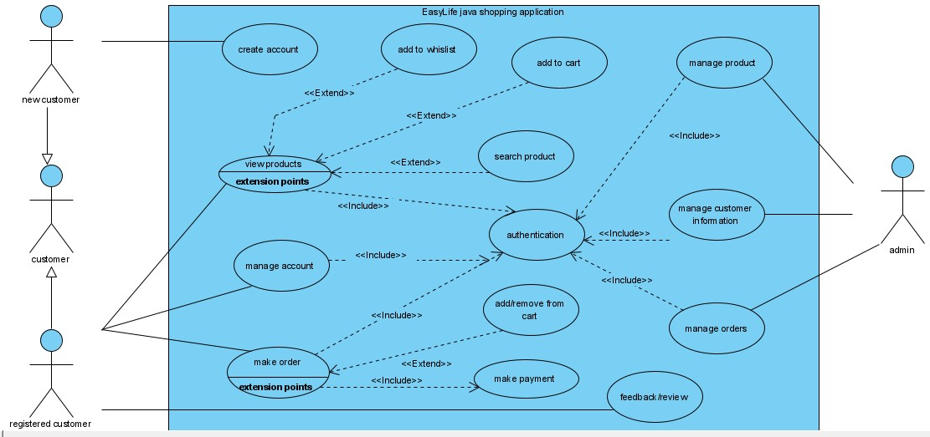

Actors

1. **Client**: Represents the customers or users of the e-commerce application. They interact with the system to perform various actions such as registering an account, logging in, searching for products, viewing product details, adding products to the cart, making purchases, tracking orders, and providing feedback.
2. **Administrator**: Represents users with administrative privileges in the e-commerce application. They have additional functionalities and responsibilities compared to regular users. Administrators can manage products (add, update, delete), manage orders (confirm, process, update), manage users, and perform other administrative tasks to maintain the smooth operation of the application.

**DESCRIPTION OF USE CASES**

**Register Account**

The "User Registration" use case enables a user to create a new account in the e-commerce application. It involves capturing and storing the necessary information provided by the user to register their account. The key points of this use case are as follows:

* 1. **Actors:**
  2. User (an individual who wants to create a new account).
  3. Super user (accounts are created for users to manage system)
  4. **Preconditions**

1. The user is accessing the e-commerce application and does not have an existing account.
   1. **Flow of Events**
2. The user initiates the registration process by providing the required information, such as username, password, email, etc.
3. The system validates the entered information for completeness and correctness.
   1. If the provided information passes the validation, the system registers the user's account by creating a new record in the user database.
   2. The system may assign a unique user ID or generate it automatically for identification purposes.
   3. **Postconditions**
   4. The user's account is successfully created and registered in the system.
   5. The user can now log in using the registered credentials to access the e-commerce application.
   6. **Alternative Flows**
4. If any of the provided information is incomplete or invalid, the system prompts the user to correct the errors and resubmit the registration form.
5. The system may enforce additional validation rules, such as password strength requirements or unique username constraints.
   1. **Exceptions**
6. In rare cases, the registration process may encounter technical issues or database errors, causing the system to fail in creating the user account. In such cases, the system should handle the exception gracefully and provide appropriate error messages to the user.

The "User Registration" use case serves as the entry point for new users to join the e-commerce application. By collecting and verifying user information, the system ensures that each registered account is unique and properly created. This use case facilitates the expansion of the user base and enables users to fully participate in the functionalities provided by the e-commerce application.

**Authentication**

The "Authentication" use case focuses on verifying the identity of users and granting them access to their accounts within the system. It ensures that only authorized individuals can log in and utilize the functionalities provided. The use case involves the following key points:

* 1. **Actors**

Users (individuals who have registered accounts in the system. Clients and Admins).

**1.2 Preconditions**

Users must have already registered an account.

**1.3 Flow of Events**

1. Users initiate the login process by entering their username and password.
2. The system validates the provided credentials against the stored user information.
3. If the credentials are valid, the system grants access to the user's account.
4. The system checks the privileges assigned to the user to determine their level of access and functionality within the system.
5. Super users or users with elevated privileges (admin) may have additional functionalities and access rights compared to regular users.

**1.4 Postconditions**

1. The user is successfully logged into their account.
2. The system recognizes the user's privileges and provides appropriate access and functionality.

**1.5 Alternative Flows**

* 1. If the entered credentials are incorrect, the system denies access and prompts the user to re-enter their login details.
  2. Users who have forgotten their passwords can follow the password recovery process to reset their password.
  3. **Exceptions:**

1. The system may have additional security measures in place, such as account lockouts after multiple failed login attempts, to prevent unauthorized access.

The "Authentication" use case plays a crucial role in ensuring the security and integrity of user accounts within the system. By validating login credentials and checking user privileges, it establishes a secure authentication process, allowing only authorized individuals to access their accounts and utilize the system's functionalities.

**View Product**

The "View Product" use case allows users to access detailed information about a specific product within the e-commerce application. By selecting a particular product, users can view its description, images, pricing, and other relevant details. This use case extends to other related functionalities, including searching for products, adding products to the cart, and adding products to the Wishlist.

**1. Search Product (Extension)**

Within the "View Product" use case, users have the ability to search for specific products. They can enter search criteria such as keywords, filters, or categories to find products that match their preferences. This functionality enhances the user's experience by providing a more targeted and efficient product search.

**2. Add to Cart (Extension)**

As part of the "View Product" use case, users can add the viewed product to their shopping cart. This functionality enables users to gather multiple products for potential purchase. Adding products to the cart allows users to review their selections, adjust quantities, and proceed to the checkout process.

**3**. **Add to Wishlist (Extension)**

Another extension of the "View Product" use case is the ability for users to add the product to their Wishlist. By adding a product to the Wishlist, users can save it for future reference or potential purchase. The Wishlist serves as a personalized collection of desired products, helping users keep track of items they are interested in.

**1.1 Actors**

1. User: An individual who wants to view product details.

**1.2 Preconditions**

* 1. The user is logged into the e-commerce application.
  2. The user has navigated to the product page or selected a specific product to view.

**1.3 Flow of Events**

1. The user selects a product from the product listing or performs a search to find a specific product.

2. The system retrieves the product information, including its description, images, price, and other relevant details.

3. The system displays the product information to the user.

4. The user can scroll through the product details, read the description, view product images, and access additional information.

5. The user may choose to add the product to their cart or Wishlist, triggering the respective extensions.

**Extensions**

**2.1 Search Product**

* 1. The user enters search criteria such as keywords, filters, or categories to find products.
  2. The system retrieves the search results based on the provided criteria.
  3. The user selects a product from the search results, and the flow continues from step 2.

**2.2 Add to Cart**

* 1. The user clicks on the "Add to Cart" button while viewing the product.
  2. The system adds the selected product to the user's shopping cart.
  3. The user may continue browsing and add more products to the cart or proceed to checkout.

**2.3 Add to Wishlist**

* 1. The user clicks on the "Add to Wishlist" button while viewing the product.
  2. The system adds the selected product to the user's Wishlist.
  3. The user can access their Wishlist to review and manage their desired products.

**1.4 Postconditions**

* 1. The user has viewed the product details and can take further actions such as adding it to the cart or Wishlist.
  2. The user can continue browsing other products or perform additional tasks within the application.

**1.5 Alternative Flow**

- If the user encounters an error or the requested product is unavailable, the system displays an appropriate error message and provides options for the user to try again or return to the previous page.

**1.6 Exceptions**

* 1. If the user is not logged in, they may be prompted to log in or create an account before accessing the product details.
  2. If the product information is incomplete or unavailable, the system displays a message indicating the unavailability and offers alternative options or recommendations to the user.

The "View Product" use case enhances the user's experience by providing comprehensive product information and facilitating related actions such as searching, adding to the cart, and adding to the Wishlist. This functionality enables users to make informed decisions, manage their shopping preferences, and engage with the application's features effectively.

**Make Order/purchase**

The "Make Order" use case enables users to initiate the purchase process for the products in their cart. It involves selecting products, confirming the order, providing payment information, and receiving an order confirmation. This use case ensures a smooth and secure transaction for users.

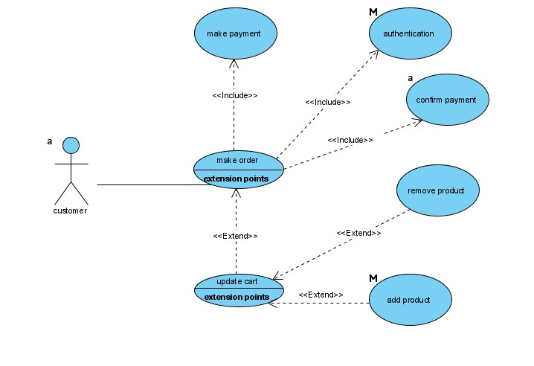

**1.1 Actors**

Customer: An individual who wants to initiate the purchase process.

**1.2 Preconditions**

* 1. The user is logged into the e-commerce application.
  2. The user has added one or more products to their cart.

**1.3 Flow of Events**

1. The user navigates to their shopping cart, where they can review the products, they have added.
2. The user selects the option to proceed with the order.
3. The system checks the availability of the products in the user's cart and verifies if they are still in stock.
4. If any of the products are out of stock, the system notifies the user and allows them to remove the out-of-stock items or proceed with the available products only.
5. The user confirms the order, indicating their intention to purchase the selected products.
6. The system calculates the total cost of the order, including taxes, shipping fees, and any applicable discounts.
7. The user selects the preferred payment method (e.g., credit card, PayPal, bank transfer).
8. If the selected payment method requires additional information (e.g., credit card details), the user provides the necessary information.
9. The system securely processes the payment using the selected payment method.
10. The system generates an order confirmation, including a unique order ID and details of the purchased items, billing information, and delivery address.
11. The system updates the inventory of the purchased products and deducts the corresponding quantities.
12. The system sends a confirmation email or PDF document to the user, acknowledging the order and providing them with the order details.

**1.4 Extensions**

**2.1 Add or Remove Items from Cart**

* 1. Before proceeding with the order, the user can modify the contents of their cart by adding or removing items.
  2. The system updates the cart accordingly, allowing the user to proceed with the modified cart content.

Discounts are automatically added by the system. The system recalculates the total cost of the order based on the applied discount.

**1.5 Postconditions**

* 1. The user has successfully completed the order process and received an order confirmation.
  2. The user's payment has been processed securely.
  3. The inventory of the purchased products has been updated.
  4. The user receives an order confirmation email with the order details.

**1.6 Alternative Flow**

* 1. If the user encounters an error during the payment process or the payment is declined, the system displays an appropriate error message and provides options for the user to retry the payment or choose an alternative payment method.

**1.7 Exceptions**

* 1. If the user's cart is empty, the system notifies the user and prompts them to add products to the cart before proceeding with the order.
  2. If any of the products in the user's cart are out of stock, the system notifies the user and allows them to remove the out-of-stock items or proceed with the available products only.
  3. If the payment information provided by the user is invalid or incomplete, the system displays an error message and prompts the user to correct the payment details.
  4. If there is a technical issue or system error during the order process, the system notifies the user and provides instructions to contact customer support for assistance.

**Manage product**

The "Manage Products" use case is specific to the administrator of the e-commerce application. It provides the necessary functionality for administrators to manage the product catalog effectively. This includes adding new products, updating existing product details, and removing products from the inventory.

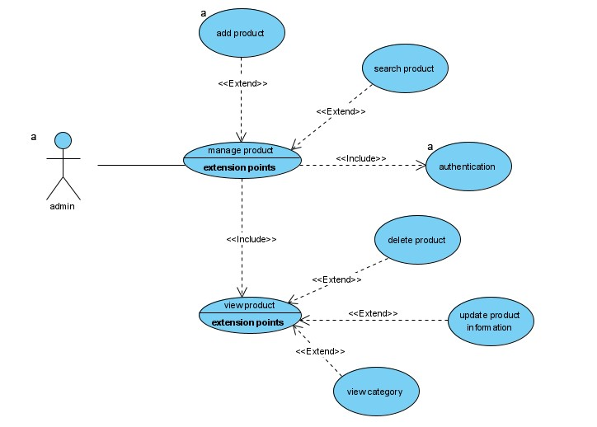

* 1. **Actors**

1. Administrator: An authorized user with administrative privileges in the e-commerce application.
   1. **Preconditions**
2. The administrator is logged into the system with administrative access.
3. The administrator has the necessary privileges to manage products.

**1.3 Flow of Events**

1. The administrator navigates to the product management section within the application.
2. The system displays the list of existing products in the catalog.
3. The administrator can perform the following actions:
   1. **Add New Product**
      * 1. The administrator selects the option to add a new product.
        2. The system presents a form for the administrator to enter the product details, such as name, description, price, etc.
        3. The administrator fills in the necessary information and submits the form.
        4. The system validates the provided details and adds the new product to the catalog.
   2. **Update Product Details:**
4. The administrator selects a specific product from the list.
5. The system displays the current details of the selected product.
6. The administrator can modify any relevant information, such as the product name, description, price, etc.
7. The administrator saves the changes, and the system updates the product details in the catalog.
   1. **Remove Product**
8. The administrator selects a product from the list.
9. The system displays a confirmation prompt to ensure the intention to remove the product.
10. The administrator confirms the removal, and the system deletes the product from the catalog.

The administrator can repeat the above actions as needed to manage multiple products.

* 1. **Extensions**
  2. **Search Products**

1. To simplify the product management process, the system may provide search functionality.
2. The administrator can search for specific products using various criteria, such as product name, category, etc.
3. The system filters the product list based on the search criteria, allowing the administrator to find and manage specific products more efficiently.
   1. **Bulk Update**
4. To expedite the process of updating product details, the system may offer a bulk update feature.
5. The administrator can select multiple products and apply changes to common attributes, such as price adjustments or category updates.
6. The system updates the selected products accordingly, saving time and effort for the administrator.

**1.5 Postconditions**

1. The administrator has successfully managed the product catalog.
2. New products have been added, existing product details have been updated, and products have been removed as per the administrator's actions.
3. The system reflects the changes in the product catalog, ensuring accurate and up-to-date information for users.

**1.6 Alternative Flow**

* 1. If the administrator does not have the necessary privileges to manage products, they are notified and restricted from accessing the product management functionality. The system displays an error message indicating that the administrator does not have sufficient privileges and cannot perform the requested action. The administrator is then redirected to a different page or presented with alternative options based on their role and permissions within the system.

**1.7 Exceptions**

* 1. In case of system errors or technical issues during the product management process, the administrator is notified and guided to contact technical support for assistance. The system detects the error or issue and displays an error message to the administrator, indicating the nature of the problem and providing instructions on how to proceed. This may include contacting technical support, providing error details for troubleshooting, or suggesting alternative actions to mitigate the issue.

**Manage Order**

The "Manage Order" use case allows the administrator to oversee and manage the orders within the e-commerce system. It involves actions such as order confirmation, processing, and handling customer requests or modifications. The use case ensures efficient order management and timely fulfillment.

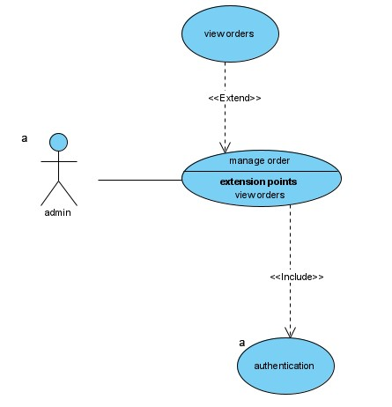

**1.1 Actors**

1. Administrator: Responsible for managing and processing orders.

**1.2 Preconditions**

1. The administrator is authenticated and logged into the e-commerce system.
2. There are existing orders within the system that require management.
3. The administrator has the necessary privileges and permissions to access the order management functionality.

**1.3 Flow of Events**

1. The administrator logs into the e-commerce system using their credentials.

2. The system authenticates the administrator's login and grants access to the order management functionalities.

3. The administrator navigates to the order management section.

4. The system retrieves a list of orders that require attention or processing.

5. The administrator selects an order from the list to view its details.

6. The system displays the order information, including customer details, order items, payment status, and shipping information.

7. The administrator reviews the order details, ensuring its accuracy and validity.

8. If any changes or modifications are necessary, such as updating the shipping address or modifying the order items, the administrator makes the required adjustments.

9. The administrator confirms the order, indicating that it is ready for processing.

10. If the customer requests a cancellation or modification before the order is shipped, the administrator handles the request accordingly, which may involve refunding the payment or adjusting the order items.

11. Once the order is confirmed, the administrator proceeds with the necessary actions for order fulfillment, such as packaging the items, arranging shipment, or coordinating with the warehouse team.

12. The administrator updates the order status to reflect its progress, such as "Processing" or "Shipped."

13. If there are any issues or concerns during the order fulfillment process, the administrator addresses them appropriately, such as contacting the customer for clarification or resolving any logistics problems.

14. The administrator generates necessary documentation, such as invoices or shipping labels, to accompany the order.

15. The system notifies the customer about the order status updates, providing relevant information such as tracking numbers or delivery estimates.

16. The administrator updates the inventory records to reflect the items that have been shipped.

17. The system archives the order for future reference and analytics purposes.

18. The administrator may generate reports or perform analysis on the order data as needed.

**1.4 Postconditions**

1. The orders are efficiently managed, processed, and fulfilled.
2. Order details and statuses are accurately updated in the system.
3. The inventory records are updated to reflect the shipped items.
4. Customers are notified about the order status updates.
5. Documentation such as invoices or shipping labels are generated and available for reference.
6. The system maintains archived records of the managed orders for future reference and analysis.
7. The administrator may generate reports or perform analysis on the order data as needed.

**1.5 Alternative Flow**

1. If there are no existing orders in the system, the administrator is notified that there are no orders to manage.

**1.6 Exceptions**

1. If the administrator does not have the necessary privileges to manage orders, they are notified and restricted from accessing the order management functionality.
2. In case of system errors or technical issues during the order management process, the administrator is notified and guided to contact technical support for assistance.
3. If an order cannot be processed due to issues such as insufficient stock or payment failure, the administrator is notified and provided with options to resolve the issue, such as contacting the customer or refunding the payment.

The "Manage Order" use case empowers the administrator to oversee and handle the order processing and fulfillment within the e-commerce system. It ensures accurate order management, timely actions, and effective communication with customers, resulting in efficient order processing and customer satisfaction.

**Manage Customer Information**

This use case involves managing customer information in the e-commerce application. It allows administrators to view and modify customer details, such as personal information, contact details, and preferences.

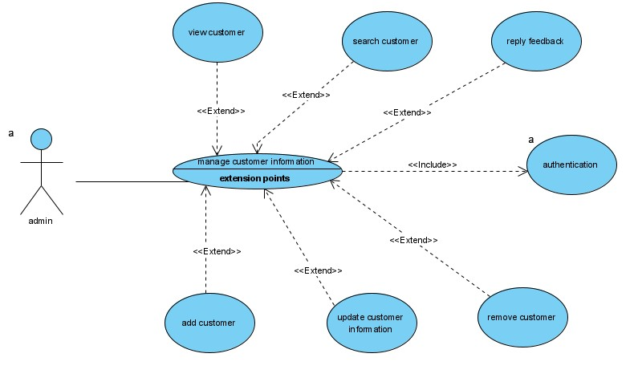

**1.1 Actors**

1. Administrator: Responsible for managing customer information.

**1.2 Preconditions**

1. The administrator must be logged into the system with appropriate privileges.

2. The system should have existing customer records.

**1.3 Flow of Events**

* 1. The administrator selects the "Manage Customer Information" option from the administrative dashboard.

1. The system presents a list of existing customers.
2. The administrator selects a specific customer from the list.
3. The system displays the customer's information, including their personal details and contact information.
4. The administrator has the option to modify any editable fields in the customer's information.
5. If the administrator chooses to make changes, they update the relevant fields and save the changes.
6. The system verifies the changes and updates the customer's information in the database.
7. The administrator can choose to view or modify information for other customers by repeating steps 3 to 7.
8. Once the desired actions are completed, the administrator exits the "Manage Customer Information" use case.

**1.4 Postconditions**

1. Customer information is successfully viewed or modified.

2. Any changes made to customer information are saved in the system.

**1.5 Alternative Flow**

1. If the administrator does not have the necessary privileges to manage customer information, they are notified and restricted from accessing this functionality.
2. If the requested customer information does not exist in the system, the administrator is notified and can choose to search for a different customer or exit the use case.

**1.6 Exceptions**

1. In case of any system errors or technical issues, the administrator is notified and guided to contact technical support for assistance.
2. If any changes made to the customer information violate validation rules or constraints, such as an invalid email format or duplicate contact information, the administrator is notified and prompted to correct the errors before saving the changes.

**SEQUENCE DIAGRAM**

A sequence diagram is used to illustrate the interaction between objects or components in a system over time. It represents the flow of messages or method calls between different entities and shows the order of these interactions. Here is an example of a sequence diagram for EasyLife:

* 1. **authentication/login**

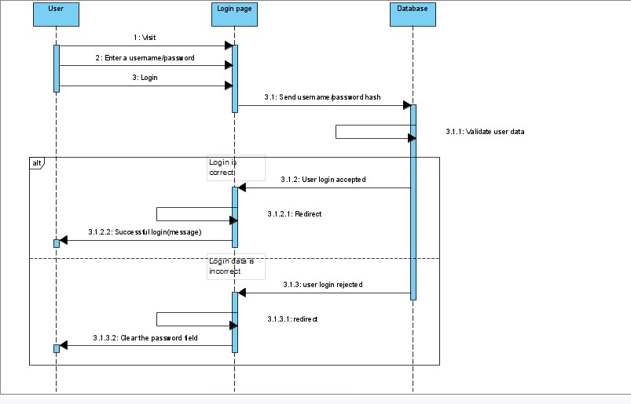

1. The user enters their login credentials (username and password) and initiates the authentication process.
2. The user interface component sends the authentication request to the authentication service.
3. The authentication service verifies the provided credentials by checking them against the stored user data or user database.
4. If the credentials are valid, the authentication service generates a token or session identifier and sends it back to the user interface component.
5. The user interface component receives the authentication success response along with the token.
6. The user interface component updates the user interface to reflect the successful authentication, granting access to the system's functionalities.
7. If the provided credentials are invalid, the authentication service sends an authentication failure response to the user interface component.
8. The user interface component displays an error message indicating the authentication failure to the user.

**1.2 Make purchase/order**

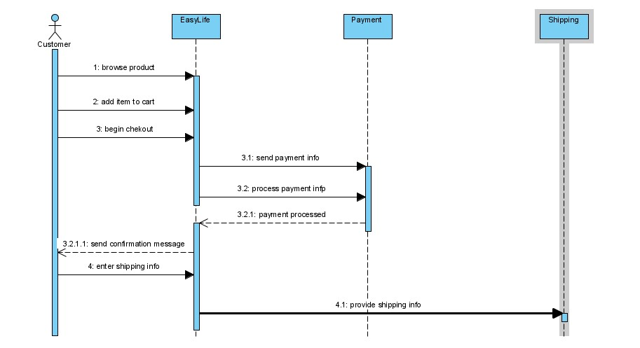

1. User browses products:

1. The user interacts with the application to browse the available products.
2. The application retrieves the product list from the database.
3. The application displays the product list to the user.

2. User selects a product:

* 1. The user chooses a specific product from the list.
  2. The application retrieves the product details from the database.
  3. The application displays the product details to the user.

3. User adds the product to the cart:

* 1. The user indicates their intention to add the product to the cart.
  2. The application adds the selected product to the user's shopping cart.
  3. The application confirms the successful addition of the product to the cart.

4. User proceeds to checkout:

* 1. The user decides to proceed to the checkout process.
  2. The application prompts the user to enter shipping and payment details.

5. User enters shipping and payment details:

* 1. The user provides the necessary shipping and payment information.
  2. The application receives and validates the entered details.

6. Application processes the payment:

* 1. The application initiates the payment process using a payment gateway.
  2. The payment gateway handles the payment transaction.
  3. The payment gateway provides a response to the application regarding the payment status.

7. Application confirms the order:

* 1. The application receives the payment response from the payment gateway.
  2. The application confirms the successful payment.
  3. The application generates an order confirmation message.
  4. The application displays the order confirmation to the user.

The summarized steps outline the user's journey from browsing products to confirming the order, including selecting a product, adding it to the cart, proceeding to checkout, entering shipping and payment details, processing the payment, and receiving the order confirmation.

**CONCLUSION**

In conclusion, the design and conceptual study phase of the application has provided a comprehensive understanding of the system's structure, functionalities, and technical requirements. By leveraging UML diagrams such as use case diagrams, sequence diagrams, and class diagrams, we have been able to go beyond a simple informal description and delve into the details necessary for executing the system.

During this phase, we have identified the actors involved in the system, including users and super users, and have defined their roles and responsibilities. We have also outlined the various use cases, such as authentication, registration, managing products, making purchases, and managing orders, to name a few. Each use case has been described with its associated flow of events, including alternative flows and exceptions.

Furthermore, the use of UML diagrams has allowed us to visualize the system's architecture and understand the relationships between different components. Class diagrams have provided insights into the data structures and relationships between classes in the application.

Overall, the design and conceptual study phase is a crucial step in the software development cycle, following the requirements analysis and specification phases. It lays the foundation for the development process by providing a clear understanding of the system's functionalities and technical requirements. The insights gained from this phase will guide the implementation and ensure a well-designed and efficient application.

**CHAPTER 5**

**IMPLEMENTATION/ DEVELOPMENT OF EASYLIFE**

**LINKS AND REFERENCES**

* 1. <https://blog.gitnux.com/digital-marketing-industry-statistics/>